/*

* Justin Mendes

* Created: November 10, 2017

* Last Edited: November 10, 2017

* Unit 4 Activity 1 Program/Question 1

* Will show the nth term of the fibonacci sequence

*/

import javax.swing.JOptionPane;

public class Fibonacci

{

public static void main(String[] args)

{

//Variable Declarations and Initializations

String message;

int fibSequence;

fibSequence = Integer.parseInt(JOptionPane.showInputDialog(null, "The first nine fibonacci numbers are listed as follows:\n1, 1, 2, 3, 5, 8, 13, 21, 34, ...\n\n"

+ "What fibonacci term would you like to see?", "Input Term", JOptionPane.QUESTION_MESSAGE));

message = "The fibonacci number at term " + fibSequence + " is " + fibonacciTerm(fibSequence);

JOptionPane.showMessageDialog(null, message);

}//end main

public static int fibonacciTerm(int term)

{

if(term <= 2)

{

return 1;

}//end if

return fibonacciTerm(term - 1) + fibonacciTerm(term - 2);

}//end method fibonacciTerm

}//end class

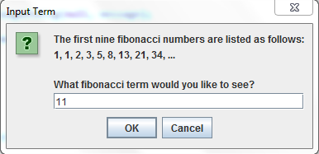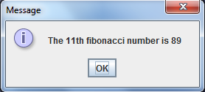

/*

* Justin Mendes

* February 8, 2016

* Grade 12 Unit 4 Activity 1 Program/Question 2

* Program will use recursion to calculate the number of ways to choose r different objects from a set of n objects

*/

**import** javax.swing.JOptionPane;

**public** **class** NChooseR

{

**public** **static** **void** main(String[] args)

{

//Variable Declarations and Initializations

**int** setOf, objects, options;

setOf = Integer.*parseInt*(JOptionPane.*showInputDialog*(**null**, "This program will calculate the number of ways\nto choose from r different objects from a n set of objects.\n\nHow many objects would you like to choose?:", "Input Set", JOptionPane.***QUESTION_MESSAGE***));

objects = Integer.*parseInt*(JOptionPane.*showInputDialog*(**null**, "How many objects are there to choose from?:", "Input Objects", JOptionPane.***QUESTION_MESSAGE***));

options = *calcFactorial*(objects) / (*calcFactorial*(setOf) * *calcFactorial*(objects - setOf));

JOptionPane.*showMessageDialog*(**null**, "There are " + options + " ways to choose " + objects + " objects from a set of " + setOf + " options.");

}//end main

**public** **static** **int** calcFactorial(**int** num)

{

**if**(num <= 0)

{

**return** 1;

}//end if

**return** (num * *calcFactorial*(num - 1));

}//end method calcOptions

}//end class

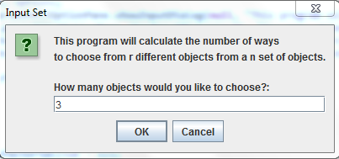

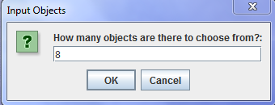

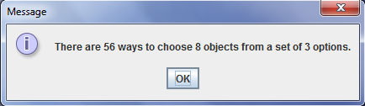

/*

* Justin Mendes

* February 10, 2017

* Grade 12 Unit 4 Activity 1 Program/Question 3

* This program will reduce a fraction using a gcd found by recursion

*/

**import** javax.swing.JOptionPane;

**public** **class** ReduceFraction

{

**public** **static** **void** main(String[] args)

{

//Variable Declarations and Initializations

**int** numerator, denominator, gcd;

numerator = Integer.*parseInt*(JOptionPane.*showInputDialog*(**null**, "Please enter the numerator for your fraction:", "Input Numerator", JOptionPane.***QUESTION_MESSAGE***));

denominator = Integer.*parseInt*(JOptionPane.*showInputDialog*(**null**, "Please enter the denominator for your fraction:", "Input Denominator", JOptionPane.***QUESTION_MESSAGE***));

gcd = *checkGCD*(numerator, denominator);

JOptionPane.*showMessageDialog*(**null**, "The fraction " + numerator + "/" + denominator + " has a GCD of " + gcd + " and can be reduced to: " + numerator / gcd + "/" + denominator / gcd);

}//end main

**public** **static** **int** checkGCD(**int** numerator, **int** denominator)

{

**if**(denominator == 0)

{

**return** numerator;

}//end if

**return** *checkGCD*(denominator, (numerator % denominator));

}//end method findGCD

}//end class

